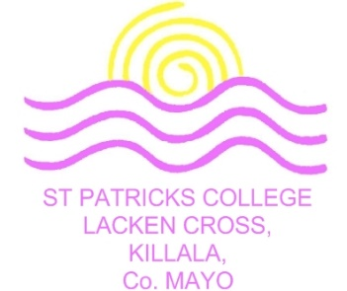

Annual Admission Notice 2022/2023
The following Annual Admission Notice has been prepared by the board of St Patrick’s College, Lacken Cross in respect of the admission of students to the school for the school year 2022/2023.
This notice was published on Monday 31st January 2022.
Total number of places available in First Year Group: | 48 Students

A copy of St Patrick’s College, Lacken Cross’s Admission Policy is available at: | School website www.lackencross.ie
 | School office (for printed copy)
 | By emailing info@lackencross.ie
An Application Form for admission to St Patrick’s College, Lacken Cross is available from 31/01/2022 at: | School website www.lackencross.ie
 | School office (for printed copy)
By emailing info@lackencross.ie
By telephoning the school 096 34177

All applications to the First Year Group in St Patrick’s College, Lacken Cross will only be accepted after the 14th February, 2022 and the closing date for receipt of applications is the 7th of March, 2022.
Applications received after this date will be considered and processed as late applications in accordance with the school’s Admission Policy.
All transfer applications to the First, Second, Third, Fourth, Fifth Year or Sixth Year Group in St Patrick’s College, Lacken Cross will only be accepted after the April 25th, 2022, and the closing date for receipt of applications is the May 31st 2022.
Applications received after this date will be considered and processed as late applications in accordance with the school’s Admission Policy.

All applicants to the First-Year Group will be notified of an offer of a place or refusal of admission by: | 14/03/2022
Successful applicants to the First Year Group must confirm their acceptance of an offer of admission by completing and returning the Acceptance Form on or before: | 04/04/2022
Note: Failure to accept an offer of admission before the relevant deadline set out above may result in the offer being withdrawn.

